Hardware Abstraction Layers, LabVIEW, and TestStand

Simple Scope HAL

Benefits of Hardware Abstraction Layers:

Reuse Code: Coding a Hardware Abstraction Layer (HAL) in an object oriented programming language allows the developer to leverage inheritance. Often, many functions/methods only need to be coded once, in the parent class. Then, any child class can reuse that code.

Design a public interface to the class: In LabVIEW, the attributes of the class are scoped as private, as such the developer of the class creates the public interface (methods) to access the attributes.

Add functionality without changing the main.vi: If carefully designed, the main code calls only parent methods or dynamic dispatch methods. New child classes can be written and tested outside of the main code. Then with a factory pattern, they can be accessed from the main.vi without any changes to main.vi

The goal behind the hardware abstraction layer (HAL) is to deploy modular code such that an engineer can replace a piece of hardware in a test system and not be required to rewrite any code. Additionally, conditions may require that the executable code run 24/7 with no rebuild of the executable during the hardware exchange.

Equally of value, is the modularity of a well designed HAL.

Abstraction layers provide benefits beyond the exchange of hardware. A software developer may determine that an abstraction layer and plug-in design may provide the necessary scalability to add different analysis functions for data or reporting of that data. The key benefit is the ability to have a “family” of functionality that can be extended without the added expense of the software developer being required to modify the main body of code.

OO’s importance in the HAL:

Object oriented (OO) programming includes a concept known as “inheritance.” Inheritance provides the ability to reuse code within a family of classes. The OO novice can think of the class as a library of functions. Functions in OO are called methods.

The following is a UML (Unified Modeling Language) Class Diagram. There is one parent class and two child classes. This would be analogous to 3 different libraries.

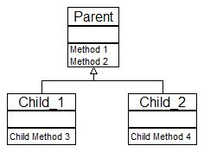

Once Method 1 and Method 2 have been coded at the parent level, this code can be reused by any child class. Additionally, the Child classes may extend the functionality of the Parent with additional methods.

A Simple Scope HAL
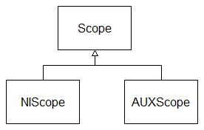

A HAL will include a parent class such as “Scope” and child classes such as “NIScope” and “AUXScope”

The development team then determines the rest of the design. There are many options for the design. First the developers look for functions or methods that would be reused accoss all of the child classes and include those at the parent level so that they can be reused. Second, the developers define the public interface to the class and include all dynamic dispatch (overriding) methods at the parent level. Third, the developers determine what will be included in the class private data. A first pass at a simple scope HAL may resemble the following:

Typical class attributes for a HAL might include: resource name, vertical setting, mode etc. In the diagram above, the NIScope class will have 2 attributes: Resource Name and Number of Channels. NIScope has its own attribute and inherits an additional attribute from its parent class. AUXScope will have only one attribute.

Methods are the actions that are performed by the class. The child methods also inherits from the parent class. As such the NIScope class has 5 methods that it can execute. Inheritance facilitates code reuse by allowing the child class to use parent methods. So NIScope and AUXScope can call reset. Reset never has to be rewritten.

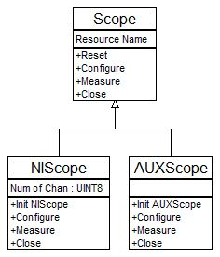

Generating the HAL Framework From the UML

There are several options for using tools to generate the LabVIEW HAL framework from the UML Class Diagram. The tool below will read the class diagram and create the shell code in the project. Note also that options exist to keep the UML in sync with the LabVIEW code as the developers code and extend the classes.
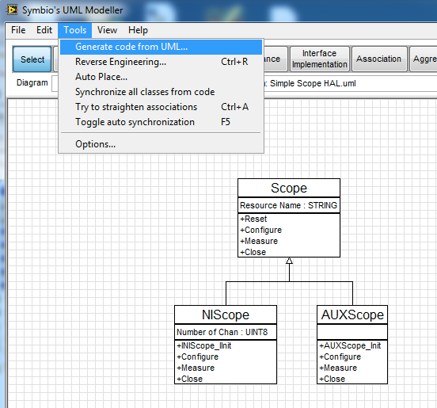

This is the project that was created from the code generation tool. The next step is to then add the functionality to the method shells that were generated.
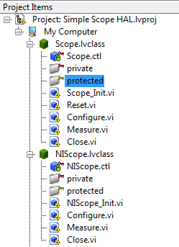

Calling the HAL From The Main.vi

In this simplistic example below the dynamic dispatch section is written with the public interface defined at the parent class. As run time, the appropriate scope will be selected and either the NIScope will execute the series of steps or the AUXScope will execute. The elegance of this design is that the main code does not change as new scopes are added to the overall project.

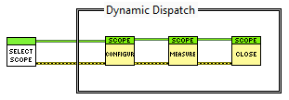
Ultimately the developer will craft a factory pattern (see a comprehensive example in the Advanced Architectures in LabVIEW course) to load new scopes that are added to the existing hierarchy.

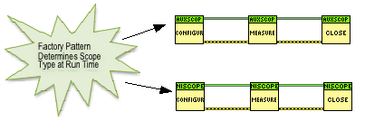

Integrating Into TestStand

The series of LabVIEW VI can also be called directly in TestStand. In this example sequence, each VI in LabVIEW is now a step in TestStand. Instead of wiring the object reference in LabVIEW, it is passed from step to step in TestStand through the LabVIEW Object reference.

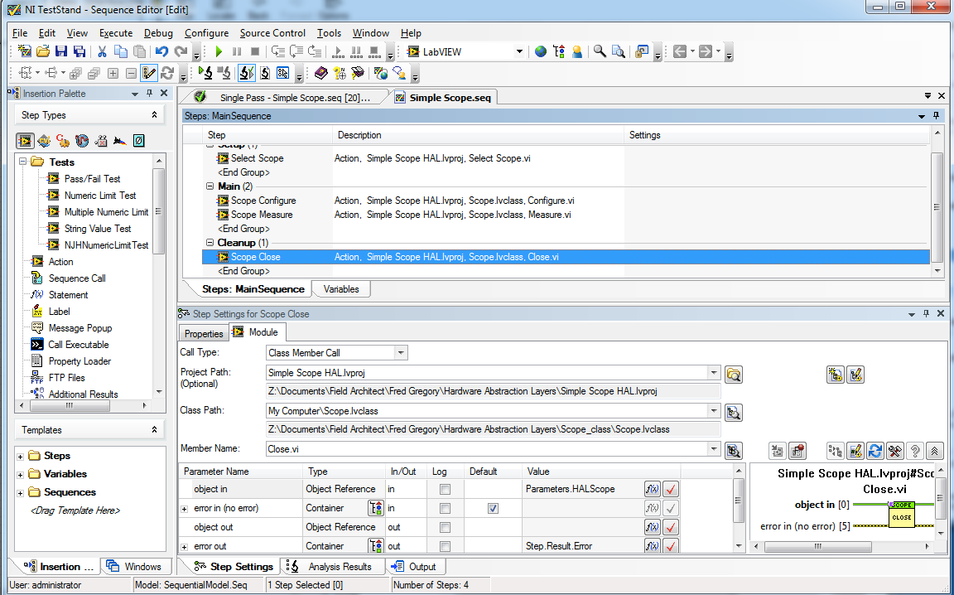

This Simple Scope.seq calls the same functions that are in the LabVIEW code. When designing and using a HAL, the team may chose to designate some people as developers of the HAL who will write and test the code in LabVIEW. Then the test team may leverage the HAL as they craft the overall test sequence and framework.

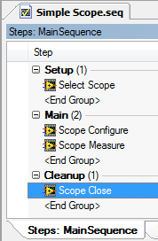

Note the call type. Just as in LabVIEW, TestStand is executing dynamic dispatch based on the object reference input to the Close.vi.

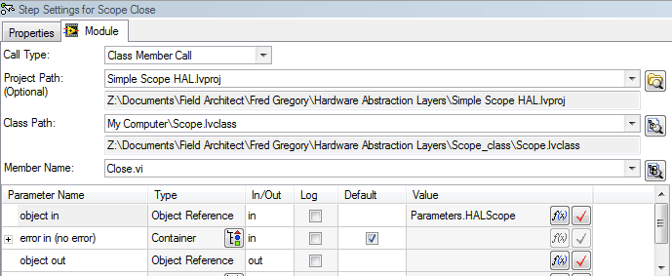

Summary:

LabVIEW and TestStand provide all the tools to easily create a HAL for use in simple and very complicated test systems. LabVIEW’s implementation of OO includes all of the key features of inheritance, such as dynamic dispatch, to implement a HAL. Additionally the design tools facilitate the development process. Then, the migration from coding the modules in LabVIEW and then rolling the code into TestStand is simple. No wrapper code needs to be writing. The LabVIEW/TestStand framework helps make the implementation side of the HAL as straight forward as possible.

Finally, the real challenge in writing a HAL in LabVIEW/TestStand is not the implementation, rather the design. The design team for a new tester, should take the time to learn OO

